WIND SPEED PREDICTION USING ARTIFICIAL INTELLIGENCE: RENEWABLE ENERGY POINT OF VIEW, A CASE STUDY OF ABUJA, NIGERIA

BY

IGHODALO, MICHAEL SEBASTINE
MATRIC NO: 16245041

A PROJECT SUBMITTED TO THE DEPARTMENT OF ELECTRICAL & ELECTRONICS, FACULTY OF ENGINEERING,
UNIVERSITY OF ABUJA, ABUJA

IN PARTIAL FULFILMENT OF THE REQUIREMENTS FOR THE AWARD OF BACHELOR OF ENGINEERING (B.Eng.) DEGREE IN ELECTRICAL AND ELECTRONICS ENGINEERING

ENGR. DR. GAFAI B. NAJASHI
PROJECT SUPERVISOR

SEPTEMBER, 2021

DECLARATION
I, Michael Ighodalo, thus declare that this work, under the supervision of Engr. Dr. Gafai B. Najashi is wholly of the author and no part of this report has been presents elsewhere in a previous application for the grant of a degree, to the best of my knowledge. All sources of information have been credited properly.

______________________________________________
Ighodalo Michael Sebastine
16245041
Electrical & Electronics Engineering

CERTIFICATION
This project report titled “WIND SPEED PREDICTION USING ARTIFICIAL INTELLIGENCE: RENEWABLE ENERGY POINT OF VIEW, A CASE STUDY OF ABUJA, NIGERIA” by I, Ighodalo Michael Sebastine, meets the requirement of the regulations governing the Award of Bachelor of Engineering (B.Eng.) degree in Electrical and Electronics Engineering of the University of Abuja and is approved for its contribution to knowledge and literacy presentation in any field or profession.

___________________________ __________________________
Engr. Dr. Gafai B. Najashi Date
Supervisor

___________________________ __________________________
Engr. Dr. Evans C. Ashigwuike Date
Head of Department, Elect/Elect Engineering

___________________________ __________________________
Engr. Tochuckwu C. Ogwueleka Date
Dean, Faculty of Engineering

___________________________ __________________________
_____________________________ Date
External Examiner

ACKNOWLEDGEMENTS
I give thanks to Almighty God, the real driving force, for aiding me in accomplishing this important task within the specified time and expanding my theoretical and practical abilities at the department. I wish to pay my heartfelt gratitude and best wishes to Dr. Najashi B. Gafai, Dr. Sani A. Isah and Dr. Sada Abdullah for their valuable guidance and supervision, which was undeniably beneficial to this project.

I am entirely grateful to my parents Mr. and Mrs. Ighodalo for guiding and supporting me throughout my academic years and my loving siblings for their full cooperation during the research period. My success and achievements are due to their prayers, moral, and financial support.

I gratefully acknowledge my indebtedness to the Head of Department, Engr. Dr. Evans Ashigwuike, and every lecturers of the great institute for their scholarly, empirical advices and tutorship during my academic program in the university.

ABSTRACT
The accurate prediction of Wind Energy Speed (WES) is very important and essential for monitoring, controlling, planning and distribution of generated power to meet consumers need due to the shortage in electricity supply in Abuja.
This study investigates the Artificial Neural Network (ANNs) method for the implementation of Support Vector Machine (SVM) algorithm, for classification, regression and outlier detection for the forecasting of wind speed from local meteorological training data gotten from the Nigerian Meteorological agency (NiMET), National Weather Research Center, located at Nnamdi Azikiwe International Airport, Bill Clinton Dr, 900102, Abuja, Nigeria from a period of over thirty years (1983-2013). For the simulation study using SVM, the obtained data is divided into two categories: training and testing with training having 70% and testing 30% of the data sets. The coefficients of determination (R2), correlation coefficient(R), Mean Square Error (MSE), Root Mean Square Error (RMSE) were calculated to demonstrate the effectiveness of the proposed machine learning models. The conventional predictions available are very dynamic, as any forecast is only really accurate 24-48 hours in advance and even then, can change several times [1], so by using Support Vector Machine for forecasting wind speed, the comparison between the predicted and actual data from the meteorological stations showed great agreement.
Keywords: Wind Energy Speed, Support Vector Machine, Energy, Forecasting, Artificial Neural Network, Power, Electricity.

TABLE OF CONTENTS
Title Page i
Declaration ii
Certification iii
Acknowledgement iv
Abstract v
Table of Contents vi
List of tables ix
List of figures x

CHAPTER ONE: INTRODUCTION
  - Background of the study 1
  - Statement of the problem 2
  - Aim and objectives 4
  - The research questions 4
  - Significance of the study 5
  - The scope and limitation of the study 5
  - Methodology and tools 5
  - Project structure 7

CHAPTER TWO: LITERATURE REVIEW
2.0 Case study 8
2.0.1 About the Federal Capital Territory, Abuja 8
2.0.2 Latitude and longitude of Abuja 10
2.1 Wind Energy 10
2.1.1 Wind classifications and climate in Abuja 10
2.1.2 Wind energy as a renewable source 12

2.2 Literature of previous studies 12
2.2.1 What is wind speed 12
2.2.2 Why and how we predict wind speed 13
2.2.3 Different methods of carrying out wind speed prediction 14
2.2.3.1 Proposed methodology for this study 15
2.2.3.2 Tools utilized for the study 15
2.2.4 Problems encountered with wind energy 16
2.2.5 Essence of the study for the harnessing of wind energy 18
2.3 Data Processing 18
2.4 Descriptive statistics 18
2.4.1 Advantage and disadvantage of descriptive statistics 18
2.4.2 Skewness and Kurtosis 18
2.4.3 Mean, Median and Standard deviation 19
2.5 Correlation 20
2.6 Normalization 20
2.7 Artificial Neural Network (ANN) 21
2.8 Support Vector Model (SVM) 23
2.8.1 Equations and structure of the SVM 24
2.8.2 Quasi logic 26

CHAPTER THREE: METHODOLOGY OF STUDY
3.1 Materials and usage 27
3.2 Area of study 27
3.3 Collection of dataset from Abuja Meteorological center 27
3.4 Methodology of research study 27
3.5 Evaluation criteria of model 29

CHAPTER FOUR: RESULT AND STATISTICAL ANALYSIS
4.1 Results and discussion for wind speed prediction 31

CHAPTER FIVE: CONCLUSION AND RECOMMENDATION
5.1 Conclusion 33
5.2 Recommendation 33
5.3 References 34
5.4 Appendix

LIST OF TABLES
Table Page
2.1 Climate data for Abuja 12
2.2 Time-scale classification for different forecasting techniques 13
2.3 Basic wind speed and power forecasting methods 15
2.4 Relationship between the Human neural network and Artificial Neural Network 22
2.5 Kernel types and its parameters 26
4.1 Statistical data from performance criteria of the model 32
5.1 Meteorological dataset of Abuja overview (1983-2013) 44
5.2 Statistical analysis of data set from SVM M1- SVM M2 44

LIST OF FIGURES
Figures Page
1.1 Relief map of Nigeria showing the stations of the study 2
1.2 Nigeria annual average wind speeds distribution (Isovents at 10 m height)
showing four different wind speed regimes 3
2.1 Kenzo Tange (1913-2005) 9
2.2 Abuja city gate 9
2.3 Map of Abuja showing the six area councils 10
2.4 How human neural network works 21
2.5 Artificial Neural Network model 21
2.6 Architecture of an artificial neural network 22
2.7 SVM graphical representation showing how two different categories are separated by hyperplane 23
3.1 Methodology of study flowchart 29
4.1 Correlation matrix of dataset 31
4.2 SVM radar plots for MSE and $R^{2}$ for both training and testing 33
4.3 SVM radar plot for R for both training and testing 33
4.4 Time series plot for Support Vector models M1, M2, M3, and M4 35
5.1 ANN-SVM model combination prediction visualization for M1, M2, M3, M4 43
5.2 M1 dataset overview 45
5.3 M2 dataset overview 45
5.4 M3 dataset overview 46
5.5 M4 dataset overview 46

CHAPTER ONE
INTRODUCTION
  - Background of the study
Wind energy is widely known to be one of greatest sources of natural energy. Wind is basically air in motion which is caused by differences in atmospheric pressure as a result of the sun’s uneven heating of the air in the atmosphere and contour shape of Earth. It is free, green (clean) and available day and night for harnessing electricity at a cheaper rate.
From the data analysis taken over the few year in Nigeria generally, all indicate that Nigeria has vast opportunities for harvesting wind for energy production [2]. This is particularly true in northern states, the mountaineous parts of the central and eastern states, and in offshore areas, where wind is abundant through out the year. The energy produced by the wind solely depends on the wind speed in the area, in the case of the study, Abuja, where the wind energy conversion system is located. Wind turbine is used to harness wind energy to produce power.
Unlike conventional power plants, wind power which is alternative to fossil fuels, is readily available, clean, renewable, widely distributed, and produces no greenhouse gas emissions to the environment during operation [3]. The generation of wind power has increased tremendously in developed countries, especially in Europe, due to the desire to reduce environmental degradation of the convectional energy sources; due to its advantage, there is a general growing interest in the wind power development in Nigeria. The world cumulative installed capacity of wind power gradually increased from 6100 MW in 1996 to 158,505 MW in 2009 and 743 GW in 2021 [4] [5].
11 years ago, in Africa, Tunisia, Morocco, and Egypt were the leading countries with installed wind power capacity of 54MW, 253 MW and 430 MW respectively [4]. In 2011, about 83 countries around the globe were using wind power on a commercial basis. Wind power production was over 2.5% of worldwide power as at 2010 and was growing at a rate of more than 25% per annum. In order to benefit from wind power in an electrical grid, it is necessary to predict the electrical energy generated by the wind [6]. In the liberalized electricity markets, the predictions of wind power from a couple of hours to a few days ahead are important [1] where the expected power production and market prices are used as a yardstick to determine the optimum demanding strategy with the least possible risk (Gomes and Castro, 2012). For effective production and prediction of wind power, one should be able to characterize the nature and predictability of the recorded data for wind speed and the related wind power to properly separate the higher dimensional data into groups using Support Vector Classifiers (SVC) and Polynomial kernel for determining the degree of the polynomial D, to be able to classify new observations in the model, giving a range of very close semblance to the expected data in the future.

  - Statement of the problem
Wind energy for the generation of electricity is very hard to harness based on wind speed strength in Abuja, (Fig 2.) due to it’s geographical location at the Northern region on the Nigerian map, hence, the power demands of consumers could not be reached. This is also due to it’s low altitude (500m) in this region as shown below:

Figure 1.1 Relief map of Nigeria showing the stations of the study (Source: Ojosu and Salawu, 1990a) [7].

Figure 1.2 Nigeria annual average wind speeds distribution (Isovents at 10 m height)
showing four different wind speed regimes (Source: Ojosu and Salawu, 1990b) [8].
Different case study on Nigeria wind speed predictions and data sheet show that the wind energy strength gradually decreases as the geographical scale progresses up North.
Taking Abuja in the study, the federal capital of the country, power deficit is one of the major problems looked upon to be tackled in the nearest future, for every residential, industrial and commercial sectors in the environment, therefore, looking at one of the most clean and efficient method of generating electricity which is harnessing power from wind energy seems like the way forward, especially when utilized properly to reach every consumer’s demand.
Lastly, there are many researches, articles and citations on wind speed predication in Nigeria as a case study but scarely any publication on Abuja specifically to forecast wind speed using Artificial Neural Networks (ANNs) methods or algorithms for classifying observations.

  - Aim and objectives
The aim of the study is to review and make forecast on the wind speed distribution in Abuja from different regions using the ANN model, Support Vector Machine (SVM) .

The specific objectives of the study will be to:
- Determine how much energy could be gotten from these areas in Abuja.
- Discuss the potential of using this renewable resource for generation of wind power.
- Classify the new observations to be used when making forcast and can act as a reference for providing sufficient data.
- Provide a good cause for setting up more Wind Energy Conversion Systems (WECS) in Abuja to increase the generated power output sufficient to satisfy consumer needs.

  - The research questions
The following research questions guide the objectives of the study:

- What is the artificial neural network model used in this case?
- How does Support Vector Machine (SVM) aid to make forecast of wind speed?
- Which Kernel functions would be used with the SVM to find the Support Vector Classifiers in higher dimensions?
- How many Kernel Functions are available?
- How would this prediction aid in resolving power outage at regions in Abuja?
- What are the factors preventing the erection of more Wind mills in Abuja for power generation?
- can Nigeria benefit from the global development in wind energy resource?
- Can investment by government at all levels and private organizations in this resource help to ease electricity crisis in Nigeria?

  - Significance of the study
The significance of the present study relies on its ability to predict wind speeds relatively close to accurate, providing a necessary prerequisite for executing sustainable integration of wind power into Abuja’s electrical grid, assisting operators in efficiently managing generated power though data forecast usage and aid to eradicate power outage in Abuja.

  - The scope and limitation of the study
The study covers on the subject of wind speed prediction using Support Vector Machine algoriths for providing forecasting data from areas in Abuja, using training data gotten from the National Space Research Development Agency (NASRDA) to feed into kernel function.
The limitations of the study are data constraint and time constraint,
- Data constraint: Inufficient data tends to impede the effficiency of the result predicted by model when carried out.
- Time constraint: The research was carried out within the institute academic calendar and required simultaneous engagements in both aspects.

1.7 Methodology and tools
The main idea of Support Vector Machines operation given as:
- Start with data in relatively low dimension.
- Move the data to higher dimension using kernel function.
- Find a Support Vector Classifier that separates the higher dimensional data into groups.

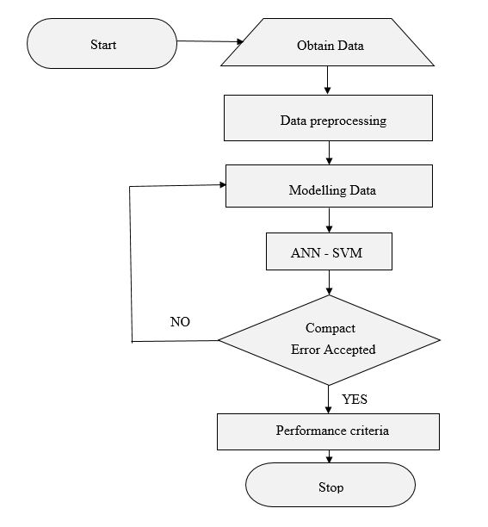
Tools
- A Personal computer or laptop.
- Data connectivity to internet.
- A Python Integrated Development Environment (IDE).
- Library installer tools or accessibility.
- Data set for analysis from NASRDA for model training.

1.8 Project structure
The rest of the paper is organized as follows: chapter 2 entail the case study of Abuja, about wind energy and literature review from previous studies on wind speed prediction using the ANN method, Support Vector Machine. Chapter 3 contains details on how data sets would be obtained and used. Chapter 4 discuss on how these data are collated, the results obtained and error checking process. Chapter 5 would be based the conclusions reached from the result observation in the study.

CHAPTER TWO
LITERATURE REVIEW
2.0 Case study

2.0.1 About the Federal Capital Territory, Abuja
Abuja is the capital of Nigeria located at the center of the country within the Federal Capital Territory (FCT). It was created from portions of Niger state, Nasarawa state and Kogi state on the 3rd February 1976 and officially became the nation’s capital on the 12th December 1991 under the leadership of the ex-President of Nigeria, General Ibrahim Badamasi Babangida (1985-1993) [9].
The word Abuja was coined from the Hausa language, derived from Mallam Abubakar Ja, meaning “Abubakar the Red” or “the Red Abubakar”, he was an indigene of the settlement before the amalgamation in 1914. Abubakar-Ja was fair in complexion. People noted with this kind of complexion were few among the native African communities and others usually called these individuals names like Usman Bature, Modu Kime, Yellow man, Red man (Ja), Oyinbo, Amina Nasa’ara etc [9]. Abubakar-Ja was the 62nd King of Zaria succeeding his brother Muhammadu Makau in 1825. Eventually, the name of the settlement, Abubakar-Ja was later abbreviated to Abuja over time [10].
The master plan of Abuja was developed by International Planning Associates (IPA), a consortium made up of three American firms: Planning Research Corporation; Wallace, Roberts and Todd; and Archisystems, a division of the Hughes Organization [10]. It defined the general structure and major design elements of the city that are now visible, the popular monumental core, Abuja city gate was designed and constructed by Japanese architect Kenzo Tange(1913-2005), with his team of city planners at Kenzo Tange and Urtec company [9].


Figure 2.1 Kenzo Tange (1913-2005) [11]. Figure 2.2 Abuja city gate [12].

Nigeria have 36 states which are grouped into six geo-political zones namely: North-Central, North-East, North-West, South-East, South-West and South-South, created during the regime of ex-President General Sani Abacha. Abuja is located in the North-Central zone of Nigeria containing six area councils, Abaji, Gwagwalada, Kwali, Kuje, Bwari and Municipal Area Council [13] as shown in figure 5. Abuja’s population has an estimate of 3,464,123 in 2021. At 1950, the population was 18,977. Abuja has grown by 186,383 since 2015, which represents a 5.69% annual change [14]. These population estimates and projections come from the latest revision of the UN World Urbanization prospects [15].
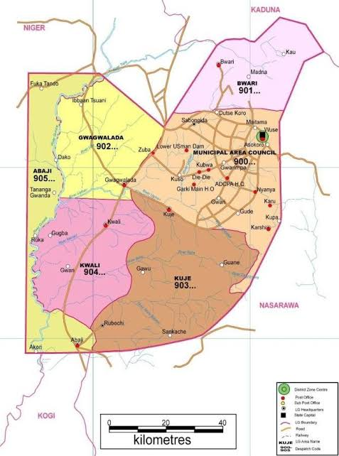
Figure 2.3 Map of Abuja showing the six area councils (Source: Sylvester Abomeh O.) [16].

2.0.2 Latitude and longitude of Abuja
The Federal Capital Territory, Abuja has a latitude and longitude coordinate of 9.072264, 7.491302 [17], encircled by nature according to the master plan built throughout the 1980s, on the grass covered Chukuku Hills [10]. It has an urban area size of 713 km² (275 sq. mi) and municipal area of 1,769 km² (683 sq. mi) [10].

2.1 Wind energy

2.1.1 Wind classification and climate in Abuja
Wind is the motion of air or gases relative to a planet’s surface. Wind occurs at different scales, from thunderstorm flows lasting tens of minutes, to local breezes generated by heating of land surfaces and lasting a few hours, to global winds resulting from the difference in absorption of solar energy between the climate zones on Earth. The two main causes of large-scale wind flow are the differential heating between the equator and the poles, and the rotation of the planet (Coriolis effect) [18].
Wind is classified based on their spatial scale, speed and direction, force causing them, region of occurrence and their effect (strength). Short busts of high-speed wind are termed Gusts. Strong winds of intermediate duration like a minute are called Squalls. Long duration winds have various names associated with their average strength, such as Breeze, Gale, Storm and Hurricane [18].

Abuja has an elevation of 360 m (1,180 ft) from sea level. Being under the Kӧppen climate classification features a tropical wet and dry climate (Kӧppen: Aw), experiencing three weather conditions annually. This includes a warm, humid rainy season and a blistering dry season. In between the two, there is a brief interlude of harmattan occasioned by the northeast trade wind, with the main feature of dust haze and dryness [19].
The rainy season begins from April and ends in October, when daytime temperatures reach 28 °C (82.4 °F) to 30 °C (86.0 °F) and night time lows hover around 22 °C (71.6 °F) to 23 °C (73.4 °F) [19]. In the dry season, daytime temperatures can soar as high as 40 °C (104.0 °F) and nighttime temperatures can dip to 12 °C (53.6 °F). Even the chilliest nights can be followed by daytime temperatures well above 30 °C (86.0 °F). The high altitudes and undulating terrain of the Federal Capital Territory act as a moderating influence on the weather of the territory. The city's inland location causes the diurnal temperature variation to be much larger than coastal cities with similar climates such as Lagos, Nigeria [19]. Rainfall in Abuja reflects the territory's location on the windward side of the Jos Plateau and the zone of rising air masses with the city receiving frequent rainfall during the rainy season from April to October every year [20].
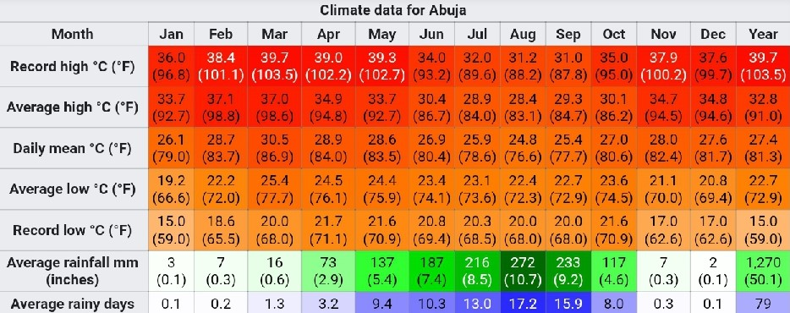
Table 2.1 Climate data for Abuja (source: Deutscher Wetterdienst.) [21].

2.1.2 Wind energy as a renewable source
Wind is a renewable energy source. Overall, through the use of wind to produce energy has fewer effects on the environment than many other energy sources [22]. Its turbines do not release emissions that can pollute the air or water (with rare exceptions), and they do not require water for cooling. Wind energy can generate electricity, while keeping the ozone layers’ undepleted [22].

2.2 Literature of previous studies

2.2.1 What is wind speed
According to meteorology, wind speed, or wind flow speed, is a fundamental atmospheric quantity caused by air movement from high to low pressure, mostly due to temperature change [23]. Wind speed is commonly measured with an Anemometer, an instrument that has a spinning wheel propelled by wind, whose speed of rotation is directly proportional to the wind speed [24]. The SI unit for measuring the wind speed is Meters per second (m/s) as recommended by the World Meteorological Organization [25] for reporting wind speeds, and is amongst others used. Since 2010 to date, the International Civil Aviation Organization (ICAO) also recommends meters per second for reporting wind speed when planes approach runways, replacing the former, Kilometers per hour (km/h) [26]. For historical reasons, other units such as Miles per hour (mph), Knots (kn) [27] or Feet per second (ft/s) are sometimes used as wind speed measurement unit.

2.2.2 Why and how we predict wind speed
Wind speed prediction is essential as it affects the amount of electrical power generated, weather forecasting, aviation and maritime operations, construction projects, growth and metabolism rate of plants, farm duties such as irrigation and wine pressing and setting of individual daily activities like hang gliding, kite flying among many others [23] [28]. In this study, we focused on predicting wind speed in Abuja to determine if it is viable as a renewable energy source. However, the biggest challenge in integrating wind power into the electric grid is its intermittency [29], therefore, by forecasting the wind speed would aid to resolve this issue.
Several wind speed forecasting methods have been reported many literatures from over the past few years, each method or technique have different time scales where they can be mostly applicable for accurate results. Shown below is a table displaying the time scales classification of different prediction techniques:
Time horizon | Range | Applications
Very short term | Few minutes to one hour ahead | • Electricity market clearing  • Real-time grid operations  • Regulation actions
Short term | One hour to several hours ahead | • Economic load dispatch planning  • Load reasonable decisions  • Operational security in electricity market
Medium term | Several hours to one week ahead | • Unit commitment decisions  • Reserve requirement decisions  • Generator online/offline decisions
Long term | One week to one or several year(s) ahead | • Maintenance planning and operation management  • Optimal operating cost  • Feasibility study for design of the wind farm

Table 2.2 Time-scale classification for different forecasting techniques [30] [31] [32] [33].

2.2.3 Different methods of carrying out wind speed prediction
Wind power forecasting methods can be generally classified into six groups namely:
- Persistence approach or Naïve Predictor.
- Physical method.
- Statistical method.
- Spatial correlation method.
- Artificial Neural Network (ANN) method.
- Hybrid method or approach.

Forecasting method | Subclass | Examples | Remarks
Persistence approach/Naïve predictor | _______ | P(t+Δt) = P(t) | - Benchmark approach.  - Really accurate for very short and short term.
Physical approach | Numeric weather predictors (NWP) | - Global Forecasting  System  - MM5  - Predictor  - HIRLAM, etc. | - Use of meteorological data such as wind speed and direction, pressure, temperature, humidity, terrain structure etc.  - Accurate for long term.
Statistical method | Time-series models | - ARX  - ARMA  - ARIMA  - Grey Predictors  - Linear Predictions  - Exponential  Smoothing, etc. | - Accurate for short-term.  - Some very good time-series models supersede ANN structures.
Spatial correlation method | _______ | - Spatial Correlation  - Fuzzy Logic  - Wavelet Transform  - Ensemble  Predictions  - Entropy based  training, etc. | - Spatial correlation is good for short term.  - Entropy based training  of model improves  performance.  - Considering non-  Gaussian error improves accuracy.
Artificial Neural Network (ANN) method | ________ | - Feed-forward  - Recurrent  - Multi-layer perception  - Support Vector Machine (SVM)  - Radial basis function  - ADALINE, etc. | - Accurate for short-term.  - Their hybrid structures  useful for medium to  long term forecasts.  - Usually, out perform  time-series models.
Hybrid method or approach | ________ | - NWP + ANN  - ANN + Fuzzy-logic = ANFIS  - Spatial  Correlation + NN  - NWP + time-series |  | - ANFIS is very good for  very-short term forecast.  - NWP + ANN structures  are very accurate for  medium and long-term  forecasts.

Table 2.3 Basic wind speed and power forecasting methods [33] [29].

2.2.3.1 Proposed methodology for this study
The proposed method or technique for forecasting wind speed from data gotten at NASRDA station in this study is the Support Vector Method (SVM), an ANN approach.

2.2.3.2 Tools utilized for the study
After acquiring the data set for analysis from NASRDA for model training, we would install a Python Integrated Development Environment (IDE), SVM library installer tools or accessibility software while being connected to the internet in a personal computer or laptop.

2.2.4 Problems encountered with wind energy
Wind energy is a green, and safe renewable source of energy, harnessed through a wind turbine for converting it to electricity or mechanical energy. The output power of the turbine is the function of the density of the air, the area swept by the turbine blades, and the cube of the wind speed [34] [35]. The primary environmental issues related to wind turbine usage include wild life safety, deforestation and soil erosion, noise, visual impact, electromagnetic interference, and local climate change [35].

Effect on wild life safety
Birds could be killed by colliding with the rotating propellers of a wind turbine or can suffer lethal injuries because of collision with the turbine towers, nacelles or other structures such as power lines, guy cables, and meteorological masts in the wind farm [36] [35]. Bats detect moving objects than stationary ones, but there is a high mortality rate among this specie close to wind farms [37]. Apart from collision, early studies has shown that 50% of dead bats were killed by sudden pressure drop near the turbine edges causing the bats to suffer barotrauma and internal hemorrhaging [38] [39]. Marine life may also be affected by the setting of the wind turbines, mostly during the construction phase, as it makes sea water turbid and introduce additional objects on the seabed, which cause damage to the benthic fauna, flora and blocks direct sunlight in the water [35].

Deforestation and soil erosion
During wind farm construction, activities such as foundation excavation may affect the local bio-system. When surface plants are removed, the surface soil would be exposed to strong wind and rainfall, resulting in soil erosion, waste water and oil from site could seep into the ground soil leading to serious environmental health problems [35]. Areas rich with wind like moors, grassland and semi desert have weak eco-system with low bio-diversity, so the construction could disrupt the eco balance and recovery would take a long time. To resolve this, the Chinese guideline suggest that wind farm construction should involve more human labor than heavy machineries to minimize the disturbance [35].

Noise
Noise is the major hinderance to the development of the wind power industry. People were found to be more annoyed with wind turbine noise than transportation noise according to other data, however, the correlation is limited [35] [40]. The two types of wind turbine noise are Tonal and Broadband noises. Tonal is between 20Hz - 100Hz, generated by aerodynamic instabilities and unstable airflows over holes, slits or a blunt trailing edge of a wind turbine. Broadband is ranging above 100Hz, generated by interaction of wind turbine blade with atmospheric turbulence and by the airflow along the airfoil surface [41].

Visual impact
Shadow flicker or strobe effect, an effect caused by the movement of the turbine blades cutting through the sun rays, becomes a human impacting problem when a number of parameters converge, including operation hours, distance from turbine and sunlight interaction. This issue is bad for people suffering from epilepsy [42].

Electromagnetic interference
Although the EM wave generated at the turbine is weak and confined to a small space, it can still create interference for wireless services such as television, FM radio, microwave broadcasting systems etc. This interference can be in resulting effects such as reflection, diffraction and so on [35].

Local climate change
Different studies have shown that wind turbine can impact local weather and climate at a region [35]. Zhou et al. [43] studied eight -year satellite data in regions of west-central Texas equipped with 2358 wind turbines and reported a temperature increase of 0.724˚C in the area. The study showed that at night the temperature increase was even more obvious [35]. Different studies are currently making research on how to reduce this issue, either by constructing large wind farms or proposing analytical models as Blade Element Momentum model, the Vortex-Wake method, and the Computational Fluid Dynamics method [44] [35].

2.2.5 Essence of the study for the harnessing of wind energy
Through the results of this study, researchers, designers and engineers would be able to make calculations closely accurate for the forecast for the level of wind strength, wind speed and from these variables, determine the power wattage of the electricity generated by a wind farm in a particular area or region.

2.3 Data Processing
Before writing about data processing, one might ask “what does data really mean?”.
According to definition from Oxford Languages dictionary, Data is simply put as facts and statistics collected together for reference or analysis [45]. Data processing is the collection and manipulation of items of data to produce meaningful information [46]. The advantages of data processing include increased productivity and profits, better decisions, more accuracy and reliability, further cost reduction, ease in storage, distribution and report making followed by better analysis and presentation.

2.4 Descriptive statistics
Descriptive statistic is the summary statistic that quantitatively describes or summarizes features from a collection of information or set of data. There are types of descriptive statistics such as mean, median, mode, skewness, kurtosis and standard deviation etc.

2.4.1 Advantage and disadvantage of descriptive statistics
Descriptive statistics provide basic information about variables in a dataset and highlight potential relationships between variables. Although, it is limited such that they only allow you to make summations about the data sets or objects that you have actually measured [47].

2.4.2 Skewness and Kurtosis
Skewness is a measure of symmetry or more precisely, the lack of symmetry. A data set or distribution is symmetric if it looks the same to the left and right of the center point [48]. Kurtosis is a measure of whether the data are heavy-tailed or light-tailed relative to a normal distribution [48].
Sample Skewness = $\frac{1}{n}\frac{\sum_{i =1}^{n}{{\left(Xi-\overline{X}\right)}^{3}}}{s^{3}}$

Sample Kurtosis = $\frac{1}{n}\frac{\sum_{i =1}^{n}{{\left(Xi-\overline{X}\right)}^{4}}}{s^{4}}$
2.4.3 Mean, Median and Standard deviation
The mean is the average of a data set calculated by summing all variables in the data set and then dividing by the number of values in the set.
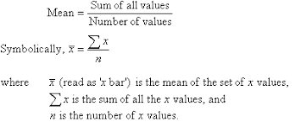 [49]
Median is the number separating the higher half of a finite data sample or distribution from a lower half.
Standard deviation is a measure of how spread out data values are around the mean, defined as the square root of the variance.
$$√\frac{\sum{\left(X-Ẋ\right)²}}{N-1}$$
Where, $X$ is the summation of the data set,
$Ẋ$ is the mean of the data
N is the number of values of data.

2.5 Correlation, R
Correlation coefficient
This is the square root of the coefficient of determination (R$²$) value. It ranges from the values 0 to 1. The performance becomes better as R approaches 1.
R = $\sqrt{\left(1-\frac{ɛ(Xi-Yi)²}{ɛ(Xi-X*i)²}\right)}$.
Coefficient of determination (R$²$) is used for showing how well a model can predict a collection of data with values between 0 and 1. The performance becomes better as R$²$ approaches 1.
$$\left(1-\frac{ɛ(Xi-Yi)²}{ɛ(Xi-X*i)²}\right)$$
2.6 Normalization
Normalization is the process of removing statistical error in repeated measured data.
The two types of normalizations are Normalized mean absolute error and Normalized root mean square error.
The normalized mean absolute error, M% is preferred for the comparison of the forecasted and measured data. As the hourly measured power significantly changes during the entire day from sunrise to sunset, so normalization is important. The relationship can be expressed as follows;
M% = $\frac{1}{x}\sum_{i=1}^{x}{\frac{E}{\max{(mi)}} }× 100$
Where E= (𝑚𝑖−𝑓𝑖) is the absolute error,
x represents the number of observations,
𝑓𝑖 and 𝑚𝑖 are the ith forecasted and measured value, respectively.
The normalized root mean square error, N% measures the absolute hourly error mean and is normalized over the maximum power output in the considered time range. The relationship can be expressed as shown below;
N% = $\frac{\sqrt{\frac{1}{x}\sum_{i=1}^{x}{E² }}}{max⁡(mi)}×100$
Where E= (𝑚𝑖−𝑓𝑖) is the absolute error,
x represents the number of observations,
𝑓𝑖 and 𝑚𝑖 are the ith forecasted and measured value, respectively.

2.7 Artificial Neural Network (ANN)
The term "Artificial Neural Network" is derived from Biological neural networks that develop the structure of a human brain. Similar to the human brain that has neurons interconnected to one another, artificial neural networks also have neurons that are interconnected to one another in various layers of the networks. These neurons are known as nodes [50].

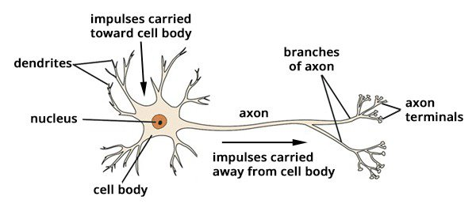
Figure 2.4 How human neural network works [51].
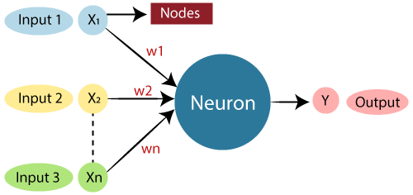
Figure 2.5 Artificial Neural Network model [50].

Human neural network | Artificial Neural Network
Dendrites | Inputs
Nucleus | Nodes
Synapses | Weights
Axons | Outputs

Table 2.4 Relationship between the Human neural network and Artificial Neural Network [50].

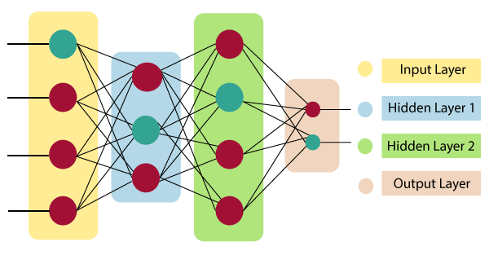
Figure 2.6 Architecture of an artificial neural network [50].

Input layer
The input layer is to receive the values of the explanatory attributes for each observation as input. The number of input nodes in an input layer is equal to the number of explanatory variables. ‘input layer’ presents the patterns to the network, which communicates to one or more hidden layers [52].
Hidden layer
The Hidden layers apply given transformations to the input values inside the network. In hidden layer, the actual processing is done via a system of weighted connections. There may be one or more hidden layers. The values entering a hidden node multiplied by weights, a set of predetermined numbers stored in the program. The weighted inputs are then added to produce a single number [52].
Output layer
Output layer receives connections from hidden layers or from input layer. It returns an output value that corresponds to the prediction of the response variable. In classification problems, there is usually only one output node. The active nodes of the output layer combine and change the data to produce the output values [52].

2.8 Support Vector Model (SVM)
Support vector machines (SVMs) are a set of supervised learning methods used for classification, regression and outlier detections.
Support Vectors are vectors that are the closest to the hyperplane, which affect the position of the hyperplane. Since these vectors support the hyperplane, hence they are called a Support vector.
Support vector regression (SVR) is a type of machine learning regression which is associated with learning algorithm equipped to analyze past or historical data for classification and regression. SVR works on the principle of structural risk minimization (SRM) from statistical learning theory [53], [54].
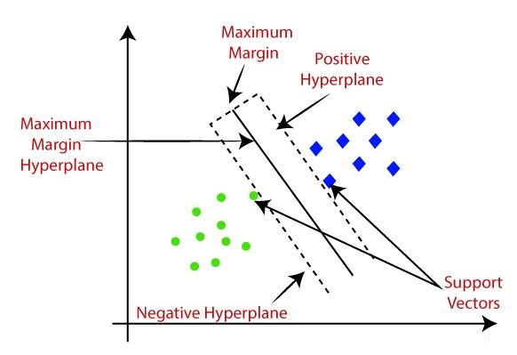
Figure 2.7 SVM graphical representation showing how two different categories are separated by hyperplane [55].

Advantage of Support Vector Model
- It is really effective for high dimensional spaces.
- SVM can still be effective in cases where number of dimensions is greater than the number of samples.
- SVM uses a subset of training points in the decision function (called support vectors), so it is also memory efficient.
- Different Kernel functions can be specified for the decision function making it versatile.
Disadvantages of Support Vector Model
- Over-fitting in choosing Kernel functions should be avoided and regularization term is crucial if the number of features is much greater than the number of samples.
- SVMs do not directly provide probability estimates, these are calculated using an expensive five-fold cross-validation.
2.8.1 Equations and structure of the SVM
There are several lib-SVM extensions developed namely:
- ʋ- classification.
- One-class classification.
- Multi-class classification.
- $∈$- regression.
- ʋ- regression.

ʋ- classification: This model allows for more control over the number of support vectors by specifying an additional parameter ʋ which approximates the fraction of support vectors.
One-class classification: This model tries to find the support of a distribution and thus allows for outlier/novelty detection.
Multi-class classification: Basically, SVMs can only solve binary classification problems. To allow for multi-class classification, lib-SVM uses the one-against-one technique by fitting all binary sub-classifiers and finding the correct class by a voting mechanism.
$∈$- regression: Here, the data points lie in between the two borders of the margin which is maximized under suitable conditions to avoid outlier inclusion.
ʋ- regression: It works with the analogue modifications of the regression model as in the classification case.

Model formulations and kernels representation
- C- classification: ${}_{α}^{min}{ \frac{1}{2}}α^{T}Q_{α-e^{T}α}$
s.t. $0≤αi≤C, i=1,…,l,$ (1)
$y^{T}α=0$,
where e is the unity vector, C is the upper bound, Q is an l by l positive semi-definite matrix, $Qij≡yiyjK\left(xi,xj\right)$, and $K\left(xi,xj\right)≡∅{\left(xi\right)}^{T}∅\left(xj\right)$ is the kernel.

- ʋ- classification: ${}_{α}^{min}{ \frac{1}{2}}α^{T}Q_{α}$
s.t. $0≤αi≤1/l, i=1,…,l,$ (2)
$$e^{T}α=ʋ$$
$y^{T}α=0$,
Where ʋ ∈ (0,1).

- One-class classification: ${}_{α}^{min}{ \frac{1}{2}}α^{T}Q_{α}$
s.t. $0≤αi≤1/{\left(vl\right)}, i=1,…,l,$ (3)
$e^{T}α=1$,

- $∈$- regression: ${}_{α,α^{*}}^{min}{ \frac{1}{2}}{\left(α-α^{*}\right)}^{T}Q\left(α-α^{*}\right)+$
$$∈\sum_{i=1}^{l}{\left(αi+{αi}^{*}\right)}+\sum_{i=1}^{l}{yi\left(αi-{αi}^{*}\right)}$$
s.t. $0≤αi,{αi}^{*}≤C, i=1,…,l,$ (4)
$\sum_{i=1}^{l}{\left(αi-{αi}^{*}\right)=0}$.

- ʋ- regression: ${}_{α,α^{*}}^{min}{ \frac{1}{2}}{\left(α-α^{*}\right)}^{T}Q\left(α-α^{*}\right)+z^{T}\left(αi-{αi}^{*}\right)$
s.t. $0≤αi,{αi}^{*}≤C, i=1,…,l,$
$e^{T}(α-α^{*})=0$,
$$e^{T}(α+α^{*})=Cʋ$$
A Kernel is a function used in SVM for helping to solve problems, proving shortcut to avoid complex calculations. Through the usage of kernels, we can calculate up to an infinite number of dimensions, enabling the predictions of wind speed from a data sheet of random values given.
Kernel | Formula | Parameters
Linear | $$u^{T}v$$ | none
Polynomial | $$γ{(u^{T}v+co)}^{d}$$ | $γ$, $d$, $co$
Radial basis fct. | exp {-$γ{|u-v|}^{2}$ } | $$γ$$
Sigmoid | $$\tanh{\{γu^{T}v+co\}}$$ | $γ$, $co$
Table 2.5 Kernel types and its parameters
2.8.2 Quasi logic
Quasi means having some resemblance usually by possession of certain attributes. Quasi logic in the case of SVM means that the correct of right prediction would be selected from the vectors that are the closest to the hyperplane in the higher dimensional representation. If the certain attributes are not met by the support vectors, then the kernel function tends to increase the dimensional plane for analysis to a higher one till a semblance or in most cases final set of values are found.

CHAPTER THREE
METHODOLOGY OF STUDY
3.1 Materials and usage
- A Personal computer or laptop.
- Data connectivity to internet.
- Matlab R2019B software with toolbox libraries.
- Data set for analysis from NASRDA for model training.

3.2 Area of study
This research was carried out with the Federal Capital Territory, Abuja as its case study, and the data set was requested and retrieved from Nigerian Meteorological agency (NiMET), National Weather Research Center, located at Nnamdi Azikiwe International Airport, Bill Clinton Dr, 900102, Abuja, Nigeria.

3.3 Collection of dataset from Abuja Meteorological center
The Abuja Meteorological data set was collected from the Nigerian Meteorological agency (NiMET), Abuja then identified and retrieved at Baze University, Airport road from the Department of Electrical, Electronics and Computer science department.

3.4 Methodology of research study
Download and install MATLAB software into a personal computer or laptop ensuring that the necessary toolbox libraries for analyzing and making predictions from data are available. After the installation process and opening the app, import dataset gotten at NiMET center for Abuja weather readings from 1983-2013 (30 years). Create a new variable, rename variable sheet e.g. AbujaDataset etc., import double values of dataset into array table and run the command, ‘corrplot(AbujaDataset)’ to display the correlation plot of the data set, through that plot we can see the distribution and what order it would follow when writing formula for the working models. In this study, we used four working models for our prediction in MATLAB namely,
      - Ws=M1 F(Rh),
      - Ws=M2 F(Rh+MaxT),
      - Ws=M3 F(Rh+MaxT+Sr),
      - Ws=M4 F(Rh+MaxT+Sr+P+MinT).
A new variable is created in MATLAB and Rh as input and Ws as Output are copied into the sheet respectively, the variable sheet can be renamed as d, f, j etc., in this case as d. Click Apps> regression learner> New session> From workspace, then import variable sheet d and choose a cross validation, for this study we choose a cross validation of 10, and then start session. Select Linear SVM> click Train, once the training is done, click on predict to see the distribution Response Plot Prediction model, export model to workspace> rename if necessary e.g. h etc.,> click ok. Duplicate the variable d and delete output Ws from the copied sheet in a new variable, rename the variable sheet, e.g. X etc. Once you are done, type in the command window, ‘yfit = h.predictFcn(X)’ to get the predicted data in MATLAB for statistical analysis. This Procedures are repeated for the remaining three working models, with their input as the variables in the bracket and Ws as the output. In the statistical analysis aspect, the validation amount was 70-30, 70 for training, 30 for testing, where the data attained from the data set is the Observed data, while the predicted data is the data gotten from MATLAB created variable sheet yfit, (It was ensured that when exporting model to workspace, the previously created variable X and yfit are deleted to enable the same naming style to be applied in the other three models left).
Figure 3.1 Methodology of study flowchart
3.5 Evaluation criteria of model
Several performance analysis metrics were used in evaluating the SVM model, including the correlation coefficient (R), coefficient of determination ($R^{2}$), mean square error (MSE) and root mean square error (RMSE). The $R^{2}$ value in training and testing indicates the difference between the observed and predicted values: for the best network, the $R^{2}$ value should be high, ranging from 0 to 1, with high values suggesting better agreement and stronger prediction.
Coefficient of Determination, $R^{2}=1-\frac{\sum_{i=1}^{N}{{\left(OB-PR\right)}^{2}}}{\sum_{i=1}^{N}{{\left(OB-\overline{OB}\right)}^{2}}}$
The R is important when determining the robustness of the relationship between expected and simulated data points.
Coefficient of Correlation, R = $√R^{2}$
The root mean square error (RMSE) is a statistical parameter that is often used to compare the forecasting errors of several working models. The lower the RMSE value the better the prediction.
Mean Squared Error, MSE = $\frac{1}{N}\sum_{i=1}^{N}{{\left(OB-PR\right)}^{2}}$
Root Mean Squared Error, RMSE = $√MSE$
These four statistical parameters are essential for evaluating the efficiency of each predictive method in this analysis of selecting the best predictive model at high accuracy. Where OB is the observed data, PR is the predicted data, $\overline{OB}$ is the average of the observed data and N is the number of data obtained.

CHAPTER FOUR
RESULT AND STATISTICAL ANALYSIS
4.1 Results and discussion for wind speed prediction
The Long-term load forecasting has been achieved for a remote area located in Abuja, Nigeria. The wind speed forecasting was done using the SVM model. The model input combinations are derived in this study utilizing the Spearman-Pearson correlation, which depicts the link between variables (solar radiation, maximum temperature, relative humidity, minimum temperature, precipitation and wind speed). Here, the inverse or direct relationship between the variables has no bearing on the strength of the correlation. From the figure below, it can be seen that the variable contribution to wind speed are 26%,15%, -2%, -36% and 20% by maximum temperature, minimum temperature, precipitation, relative humidity and solar radiation respectively.
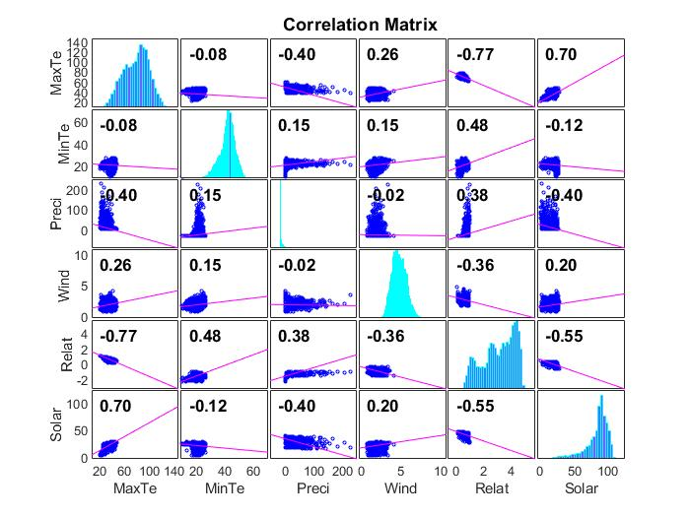
Figure 4.1 Correlation matrix of dataset
MATLAB software (R2019b) is used to implement the SVM model along with Microsoft Excel (2016). To prevent overfitting caused by various causes, adequate amount of hidden nodes was determined in the ANN modelling. The linear SVM algorithm, under regression learner is used in training the model, due to its excellent performance in recent studies. Here below show the Performance criteria of the model. As shown in Figure 4.1, the stationary and significant variables with probability less than 0.05 (P<0.05) indicates the high strength of the linear correlations, and the negative correlation values show an inverse relationship between the two variables. As a result, value's weakness of the correlation indicates that traditional methods are ineffective in modeling such complex interactions and that there is a significant need to train or forecast with more robust models.

 | Calibration (Training)
 | MSE | RMSE | MAE | MAPE | $$R^{2}$$ | R
SVM 1 | 0.152733 | 0.390811 | 0.308603 | 17.62% | 0.127237 | 0.356703
SVM 2 | 0.213351 | 0.4619 | 0.379301 | 24.43% | 0.000148 | 0.012173
SVM 3 | 0.214596 | 0.463245 | 0.380058 | 24.31% | 0.000789 | 0.028097
SVM 4 | 0.227307 | 0.476768 | 0.390052 | 24.89% | 2.53E-05 | 0.005026
 | Verification (Testing)
 | MSE | RMSE | MAE | MAPE | $$R^{2}$$ | R
SVM 1 | 0.141497 | 0.376161 | 0.295991 | 18.45% | 0.152263 | 0.390209
SVM 2 | 0.241034 | 0.490952 | 0.405652 | 27.67% | 0.001382 | 0.037172
SVM 3 | 0.245695 | 0.495676 | 0.408739 | 27.71% | 0.000766 | 0.027682
SVM 4 | 0.250736 | 0.500735 | 0.41133 | 27.83% | 0.000271 | 0.016469

Table 4.1 Statistical data from performance criteria of the model, 70% and 30% respectively

The first combination, SVM 1, has a high accuracy based on its positive value to the coefficient of determination, the others are a poor fit for the data, meaning that they are not explained by the model with MSE = 0.141497, RMSE = 0.376161, MAE = 0.295991, MAPE = 18.45%, $R^{2}$ = 0.152263 and R = 0.390209.
By using radar plot for displaying the MSE, $R^{2}$, R values in both training and testing models for SVM (M1-M4). Radar plot is great for determining which variable in a dataset are scoring low or high, making them ideal for presenting performance. Its values range from 0 to 1.
Figure 4.2 SVM radar plots for MSE and $R^{2}$ for both training and testing

Figure 4.3 SVM radar plot for R for both training and testing

The prediction generated from SVM is analyzed using the time series plot to show the degree of agreement between the observed wind speed values and the forecasted wind speed values vary with respect to time, when these variables overlap in the plot, it means that they are agreeable. The time series plot for the best SVM model (M1) is shown it can be seen that in M1, the predicted value nearly overlaps with the observed value, this implies that there is a higher degree of agreement between the observed and predicted values.

Figure 4.4 Time series plot for Support Vector models M1, M2, M3, and M4
CHAPTER FIVE
CONCLUSION AND RECOMMENDATION
5.1 Conclusion
This study proposes an approach for applying machine learning models to optimizing the harnessing of wind energy, which forecasting its speed. The neural predictor ANN-SVM is used to feed raw data for solar radiation, temperature, relative humidity, wind speed and precipitation into mathematical models relative to the specified regions in Abuja. The correlation plot revealed that maximum and minimum temperature respectively including the solar radiation of the environment are the effective parameters for forecasting strong wind speed in as much as to meet consumer needs. From the statistical analysis, M1 produced a reliability of $R^{2}$=0.152263 and RMSE=0.376161, outperforming other models in the estimation of wind speed. Furthermore, investigations demonstrated that Support Vector Model is adaptive for predicting the wind speed from large dataset with less error.

5.2 Recommendation
This study implemented the Support Vector Model (SVM) in the prediction of wind speed. For future researches based on carrying out wind speed forecast, the following recommendations should be considered;
1. More climate input parameters should be considered in order to achieve high efficiency and low error.
2. SVM should be combined with other machine learning models in order to improve its predictive accuracy.

5.3 References
[1] | Surf Kite, "How to read a wind weather forecast," The Kite Surf Center, 14 October 2019. [Online]. Available: https://www.thekitesurfcentre.com/news/how-to-read-a-wind-weather-forecast.
[2] | Nwagbo G., Oyedepo S. O, "Renewable Energy in Nigeria," 12 December 2017. [Online]. Available: http://large.stanford.edu/courses/2017/ph240/nwagbo2.
[3] | Hussain T., "Wind Energy: A Nigerian Perspective," 13 April 2021. [Online]. Available: www.linkedin.com/pulse/wind-energy-nigerian-perspective-hussain-tijani.
[4] | GWEC, "GWEC: Global Wind Energy Outlook," 11 June 2014. [Online]. Available: http://www.gwec.net/wpcontent/uploads4/2012/11/GWEO\_2012\_low Res.pdf.
[5] | GWEC, "Global Wind Report 2021," 2021. [Online]. Available: https://gwec.net/global-wind-report-2021.
[6] | Ryoichi H., "Integration of Distributed Energy Resources in Power Systems," 2016. [Online]. Available: https://www.sciencedirect.com/book/9780128032121/integration-of-distributed-energy-resources-in-power-systems.
[7] | Ojosu J.O., Salawu R.I. 1990a, "A survey of wind energy potential in Nigeria," in Solar and Wind Technology, 7 ed., pp. 155-167.
[8] | Ojosu J.O., Salawu R.I. 1990b, "An evaluation of wind energy potential as a power generation source in Nigeria," in Solar and Wind Technology, 7 ed., pp. 663-673.
[9] | Abubakar .T, "Origin and meaning of Abuja - The capital city of Nigeria," November 2020. [Online]. Available: https://www.researchgate.net/publication/345166243_Origin_and_Meaning_of_Abuja_the_Capital_city_of_Nigeria.
[10] | Oasdom, "History of Nigeria - How it beacme Nigeria's capital," 9 October 2016. [Online]. Available: https://www.oasdom.com/history-of-abuja-how-it-was-created/.
[11] | Nicolas Janberg, "Kenzo Tange," Structurae, 2018. [Online]. Available: https://structurae.net/en/persons/kenzo-tange/media.
[12] | Fatima M., "Abuja city gate," [Online]. Available: https://artsandculture.google.com/asset/abuja-city-gate-fatima-muhammed/QwH1QuvLmeVsYg.
[13] | Rodw, "Geopolitical zones of NIgeria," 2 November 2021. [Online]. Available: https://en.m.wikipedia.org/wiki/Geopolitical_zones_of_Nigeria.
[14] | World population review, "Abuja populaon 2021 (Demographics, Maps, Graphs)," [Online]. Available: https://worldpopulationreview.com/world-cities/abuja-populaon.
[15] | UNITED NATIONS, "Population division world urbanization prospects 2018," 2018. [Online]. Available: https://esa.un.org/undp/wup.
[16] | Sylvester A. O., "Manpower development and employees' performance: Qualitative assessment of small and medium scale business in Abuja Nigeria," January 2017. [Online]. Available: https://www.researchgate.net/publication/318653677_Manpower_Development_and_Employees'_Performance_Qualitative.
[17] | LatLong.net, "Abuja, Nigeria," 5 July 2019. [Online]. Available: https://www.latlong.net/place/abuja-nigeria-3321.html.
[18] | Femkemilene, "Wind," 25 October 2021. [Online]. Available: https://en.m.wikipedia.org/wiki/Wind.
[19] | Wikipedia, "Abuja," 17 November 2021. [Online]. Available: https://en.wikipedia.org/wiki/Abuja.
[20] | Touristlink, "Abuja Nigeria Tourist Information," 24 March 2013. [Online]. Available: http://www.touristlink.com/nigeria/abuja/overview.html. [Accessed 30 August 2013].
[21] | Deutscher Wetterdienst, "Klimatafel von Abuja," 1 October 2012. [Online]. Available: https://www.dwd.de/DWD/klima/beratung/ak/ak_651250_kt.pdf.
[22] | EIA, "Wind explained: Wind energy and the environment," 9 December 2020. [Online]. Available: https://www.eia.gov/energyexplained/wind/wind-energy-and-the-environment.php.
[23] | M. Mounier, "Wind speed," Wikipedia, 18 November 2021. [Online]. Available: https://en.m.wikipedia.org/wiki/Wind_speed.
[24] | National Geographic, "Anemometer," 2021. [Online]. Available: https://www.nationalgeographic.org/encyclopedia/anemometer.
[25] | World Meteorological Organization (WMO), "Guide to Meteorological Instruments and Methods of Observation," priliminary seventh ed., Vols. WMO-No. 8, Geneva: Secretariat of the World Meteorological Organization, 2006.
[26] | International Civil Aviation Organization, "International Standards and Recommended Practices - Units of Measurement to be Used in Air and Ground Operations," 2014-2015.
[27] | ThoughtCo, "Measuring Wind Speed in Knots - The reason why sea winds are measured in knots at all has to do with maritime tradition," [Online]. Available: https://www.thoughtco.com/measuring-wind-speed-in-knots-3444011.
[28] | Emily M., Cleveland C., "Encyclopedia of Earth: Abiotic factor," National Council for Science and the Environment, 08 June 2013. [Online]. Available: http://www.eoearth.org/article/Abiotic_factor?topic=49461.
[29] | Saurabh S. Soman, Hamidreza Zareipour, Om Malik, Paras Mandal, "A Review of Wind Power and Wind Speed Forecasting Methods With Different Time Horizons," pp. 1-8, 2011.
[30] | Wang, X.C., Guo, P. and Huang, X.B., "A Review of Wind Power Forecasting Models," Energy Procedia, vol. 12, pp. 770-778, 2011.
[31] | Zhao, D.M., Zhu, Y.C. and Zhang, X., "Research on Wind Power Forecasting in Wind Farms," in Proceedings of the 2011 IEEE Power Engineering and Automation Conference, 8-9 September 2011, Wuhan, 2011.
[32] | Zhao, X., Wang, S.X. and Li, T., "Review of Evaluation Criteria and Main Methods of Wind Power Forecasting," Energy Procedia, vol. 12, pp. 761-769, 2011.
[33] | Chang, W.-Y., "A Literature Review of Wind Forecasting Methods," Journal of Power and Energy Engineering, vol. 2, pp. 161-168, 2014.
[34] | Ellenbogen J.M., Grace S., Heiger-Bernays W.J., Manwell J.F., Mills D.A., Sullivan K.A., et al, "Wind turbine health impact study: report of independent expert panel," Massachusetts, US, 2012.
[35] | Dai K., Bergot A., Liang C., Xiang W-N., Huang Z., "Renewable Energy: Environmental issues associated with wind energy," Elsevier, vol. 75, pp. 911-921, 2015.
[36] | Drewitt A.L., Langston R.H., "Accessing the impact of wind farms on birds," Ibis, vol. 148, pp. 29-42, 2006.
[37] | Philip H-S., Mccarty J.K., "Bats avoid moving objects more successfully than stationary ones," Nature, vol. 275, pp. 743-4, 1978.
[38] | EPRI (Electric Power Research Institute), "Environmental aspects of renewable energy," 2012. [Online]. Available: http://mydocs.epri.com/docs/Portfolio/PDF/2012_P179.pdf.
[39] | Baerwald E.F., D'amours G.H., Klug B.J., Barclay R.M.R., "Barotrauma is a significant cause of bat fatalities at wind turbines," 2008.
[40] | Pedersen E., Persson W.K., "Perception and annoyance due to wind turbine noise-a dose-respond relationship," Acoust Soc Am, vol. 116, no. 6, pp. 3460-70, 2004.
[41] | Pantazopoulou G., "Noise issues and standards for domestic wind turbines," BRE Acoustics, 2009.
[42] | Harding G., Harding P., Wilkins A., "Wind turbines, flicker, and photosensitive epilepsy: characterizing the flashing that may precipitate seizure and optimizing guidelines to prevent them," Epilepsia, vol. 49, pp. 1095-8, 2008.
[43] | Zhou L., Tian Y., Roy S.B., Thorncraft C., Bosart L.F., Hu Y., "Impact of wind farms on land surface temperature," Nat Clim Change, vol. 2, pp. 539-43, 2012.
[44] | Santa Maria M.R.V., Jacobson M.Z., "Investigating the effect of Large wind farms on energy in the atmosphere," Energies, vol. 2, pp. 816-38, 2009.
[45] | J. A. W. E. S. C. &. O. U. P. Simpson, The Oxford English Dictionary, Oxford: Clarendon Press, 1989.
[46] | Wikipedia, "Data processing," Wikipedia, 1 January 2022. [Online]. Available: https://en.wikipedia.org/wiki/Data_processing. [Accessed 2 January 2022].
[47] | Laerd statistics, "FAQs - Descriptive and Inferential Statistics," Lund Research Ltd, 2018. [Online]. Available: https://statistics.laerd.com/statistical-guides/descriptive-inferential-statistics-faqs.php.
[48] | NIST SEMATECH, "Measures of Skewness and Kurtosis," in Engineering Statistics Handbook, NIST SEMATECH.
[49] | G.S Rehill, "Mean," mathsteacher.com Pty Ltd, 2020. [Online]. Available: https://www.mathsteacher.com.au/year9/ch17_statistics/01_mean/mean.htm.
[50] | JavaTpoint, "Artificial Neural Network Tutorial," JavaTpoint, 2020. [Online]. Available: https://www.javatpoint.com/artificial-neural-network. [Accessed 2 January 2021].
[51] | S. Singh, "How does the human neural network work?," Quora, 2021. [Online]. Available: https://www.quora.com/How-does-the-human-neural-network-work.
[52] | S. Sharma, "Artificial Neural Network (ANN) in Machine Learning," TechTarget, Inc, 8 August 2017. [Online]. Available: https://www.datasciencecentral.com/profiles/blogs/artificial-neural-network-ann-in-machine-learninga. [Accessed 30 December 2020].
[53] | V. Vapnik and A. Lerner, "Pattern recognition using generalized portrait method," Automation and Remote Control, vol. 24, 1963.
[54] | T. Joachims, "Text categorization with support vector machines: Learning with many relevant features," in Machine Learning: ECML-98, Springer Berlin Heidelberg, 1998, p. 137–142.
[55] | JavaTpoint, "Support Vector Machine Algorithm," JavaTpoint, [Online]. Available: https://www.javatpoint.com/machine-learning-support-vector-machine-algorithm. [Accessed 3 January 2021].

5.4 Appendices

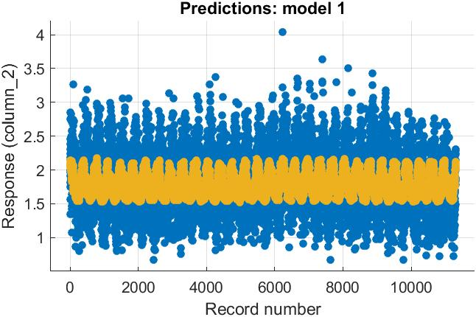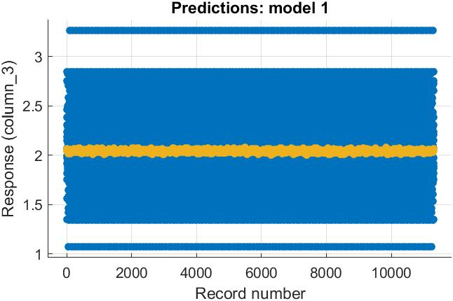
ANN-SVM 1 ANN-SVM 2

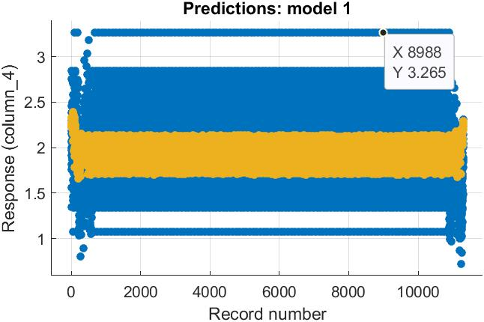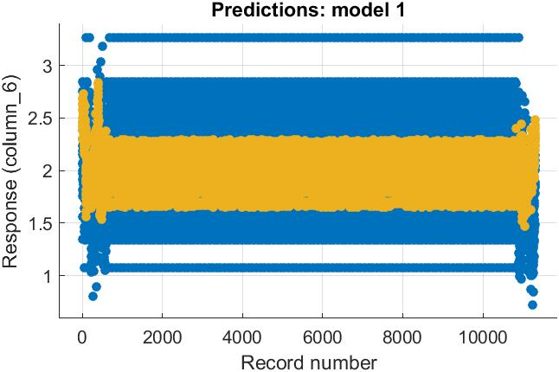
ANN-SVM 3 ANN-SVM 4

Figure 5.1 ANN-SVM model combination prediction visualization for M1, M2, M3, M4

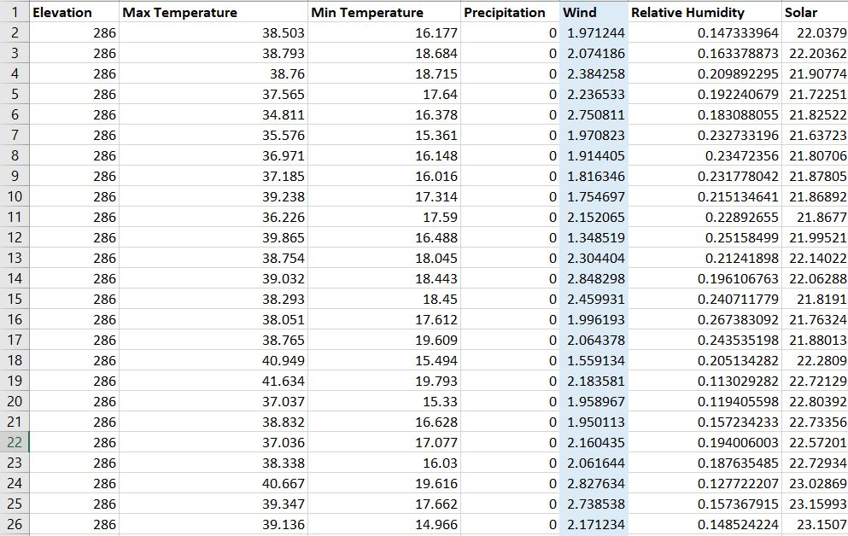
Table 5.1 Meteorological dataset of Abuja overview (1983-2013)

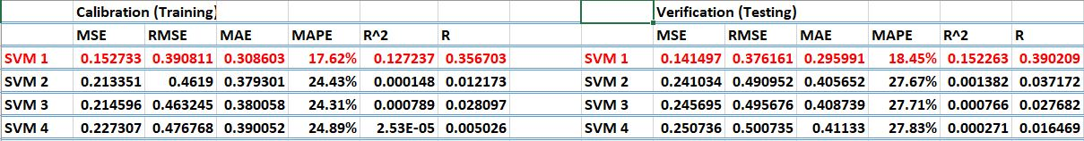
Table 5.2 Statistical analysis of data set from SVM M1- SVM M4

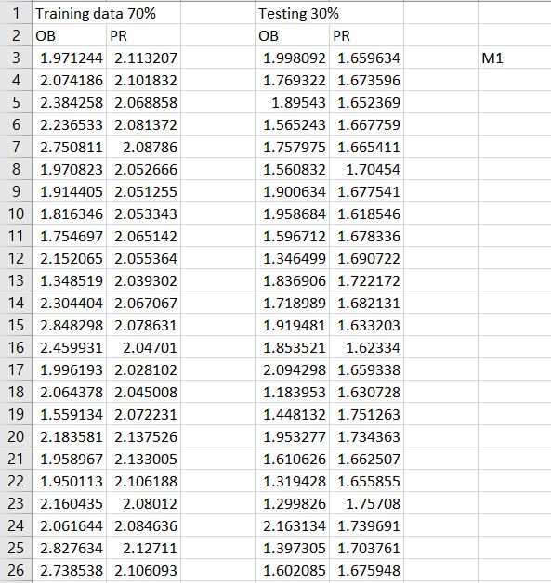Figure 5.2 M1 dataset overview
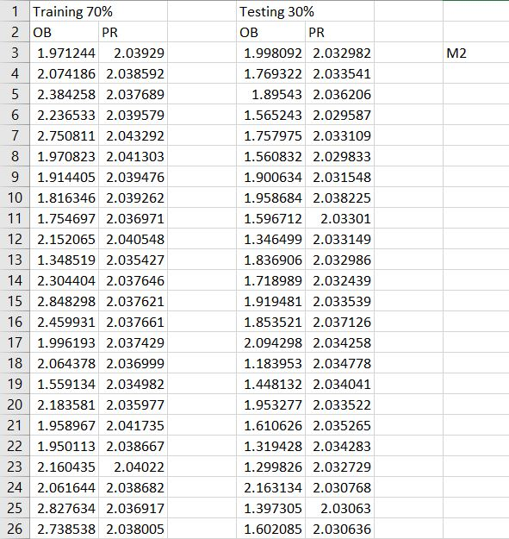Figure 5.3 M2 dataset overview
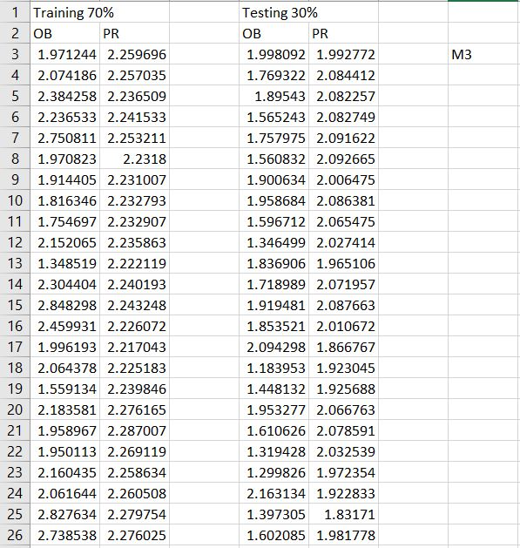Figure 5.4 M3 dataset overview
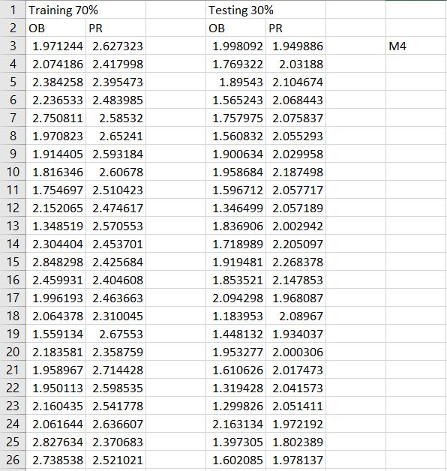Figure 5.5 M4 dataset overview

